|  |  |
| --- | --- |
|  | **Pimpri Chinchwad Education Trust’s**  **Pimpri Chinchwad College of Engineering** |

|  |
| --- |
| **Practical Assignment Solution-2** |

**Roll No: 21**

**Name of Student: Kiran Chavan Submission Date:** 27 / 02 /2021

1. Create a class Employee with following data members:

Data Members: Emp_no, Emp_name, Basic_Salary, and Designation.

Create a Java program to do the following operations on it.

Add constructor with Object as parameter to initialize class variables.

Add a function calculate() which calculates the DA, HRA, PF and IT on the salary of

employee

Print all the employee information to user.

**Solution:**

import java.util.*;

class Employee{

private int Emp_no , Basic_Salary;

private String Emp_name , Designation;

private float DA , HRA , GS , PF , IT , NS;

public Employee(int Emp_no,String Emp_name,int Basic_Salary,String Designation){

this.Emp_no = Emp_no;

this.Emp_name = Emp_name;

this.Basic_Salary = Basic_Salary;

this.Designation = Designation;

}

void Calculates(){

DA = (Basic_Salary/100)*60;

HRA = (Basic_Salary/100)*25;

GS = Basic_Salary + DA + HRA;

PF = (GS/100)*12;

IT = (GS/100)*10;

NS = GS - (PF + IT);

}

void Display(){

System.out.println("\n ===========Employee Info========");

System.out.println("\n Employee Number : "+Emp_no);

System.out.println("\n Employee Name : "+Emp_name);

System.out.println("\n Employee Basic Salary : "+Basic_Salary);

System.out.println("\n Employee Designation : "+Designation);

System.out.println("\n Employee DA : "+DA);

System.out.println("\n Employee HRA : "+HRA);

System.out.println("\n Employee GS : "+GS);

System.out.println("\n Employee PF : "+PF);

System.out.println("\n Employee IT : "+IT);

System.out.println("\n Employee Net Salary : "+NS);

}

}

class A2Q1{

public static void main(String []args){

Scanner sc = new Scanner(System.in);

System.out.print("Enter the Employee Id : ");

int Emp_no = sc.nextInt();

System.out.print("Enter the Employee Name : ");

String Emp_name = sc.next();

System.out.print("Enter the Employee Basic Salary : ");

int Basic_Salary = sc.nextInt();

System.out.print("Enter the Employee Designation : ");

String Designation = sc.next();

Employee e = new Employee(Emp_no,Emp_name,Basic_Salary,Designation);

e.Calculates();

e.Display();

}

}

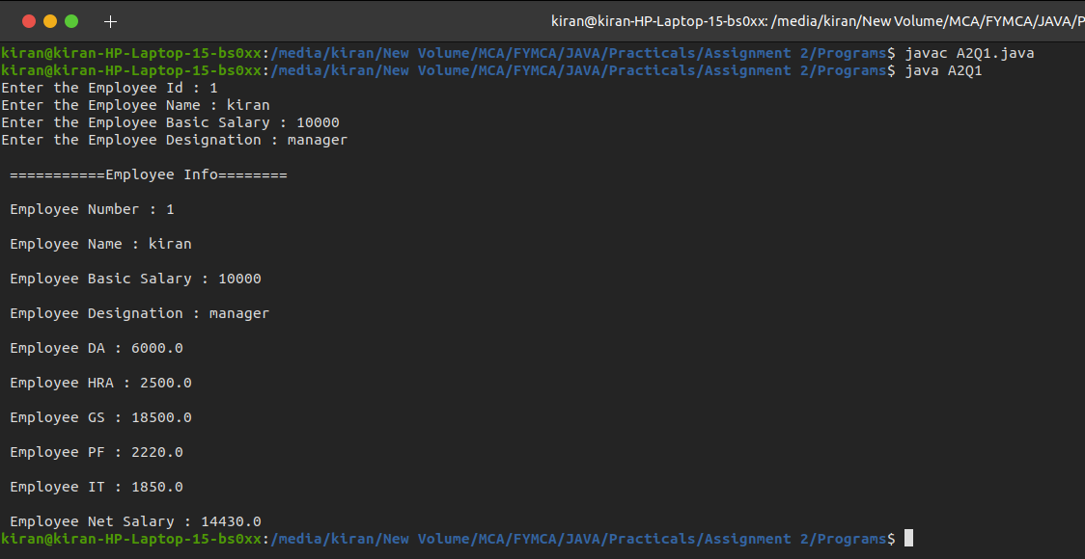**Output:**

2. Create a class Date with following data members and member functions:

Data Members: Year, Month and Day.

Member Functions: acceptDate():

It accepts date from the user in yyyy-mm-dd.

displayDate():

It display date to the user.

dateDifference(Date, Date): It finds the difference between two date.

Create a Java program to accept current date and birth date of user, find the current

age and display it back to user in the form of yy-mm-dd.

**Solution:**

import java.util.*;

class Date{

private int year,month,day;

String currentDate , birthDate;

void acceptDate(){

Scanner sc = new Scanner(System.in);

System.out.print("Enter the Birth Date : (yyyy-mm-dd) ");

birthDate = sc.next();

System.out.print("Enter the Current Date : (yyyy-mm-dd) ");

currentDate = sc.next();

}

void dateDifference(){

int months[] = {31,28,31,30,31,30,31,31,30,31,30,31};

int CurrentDate[] = splitDate(currentDate);

int BirthDate[] = splitDate(birthDate);

if(BirthDate[2]>CurrentDate[2]){

CurrentDate[1]--;

CurrentDate[2] += months[BirthDate[1]-1];

}

if(BirthDate[1]>CurrentDate[1]){

CurrentDate[0]--;

CurrentDate[1] += 12;

}

day = CurrentDate[2] - BirthDate[2];

month = CurrentDate[1] - BirthDate[1];

year = CurrentDate[0] - BirthDate[0];

}

static int[] splitDate(String date){

String str[] = date.split("[-]");

int a[] = new int[str.length];

for(int i=0;i<str.length;i++){

a[i] = Integer.parseInt(str[i]);

}

return a;

}

void displayDate(){

System.out.println(year+"-"+month+"-"+day);

System.out.println(year+" years "+month+" months "+day+" old");

}

}

class A2Q2{

public static void main(String args[]){

Date d = new Date();

d.acceptDate();

d.dateDifference();

d.displayDate();

}

}

**Output:**

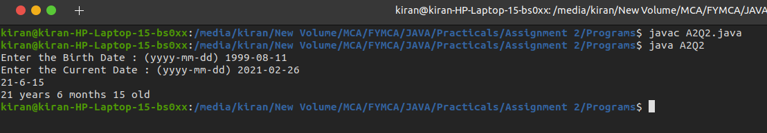

3. An organization maintains the records of all its employees as per the designation and

the hierarchy of the designation. Each employee has his basic information and

allowances are decided as per the hierarchy of the designation. e. g. NormalEmployee gets basic salary Rs. 5000 per month. If that employee is Manager, he gets

20% of basic as HRA additional. If that employee is Head of any department, he gets

HRA + 10% of basic as Child Education Allowance. Use inheritance to solve this

problem.

**Solution :**

import java.util.*;

class Employee{

protected int Basic_Salary;

protected float HRA , CEA;

public Employee(int bs){

this.Basic_Salary = bs;

}

void calculate(){

float total = Basic_Salary + HRA + CEA;

System.out.println("========================");

System.out.println("Basic Salary : "+Basic_Salary);

System.out.println("HRA : "+HRA);

System.out.println("Chil Education Allowance : "+CEA);

System.out.println("Total Salary :"+total);

}

}

class Manager extends Employee{

public Manager(int sal){

super(sal);

this.HRA = ((Basic_Salary/100)*20);

}

}

class HOD extends Manager{

public HOD(int sal){

super(sal);

this.CEA = ((Basic_Salary/100)*10);

}

}

class A2Q3{

public static void main(String args[]){

Scanner sc = new Scanner(System.in);

System.out.print("Enter Basic Salary : ");

int sal = sc.nextInt();

System.out.println("\n Employee Salary : ");

Employee emp = new Employee(sal);

emp.calculate();

System.out.println("\n Manager Salary : ");

Manager mng = new Manager(sal);

mng.calculate();

System.out.println("\n HOD Salary : ");

HOD hod = new HOD(sal);

hod.calculate();

}

}

**Output :**

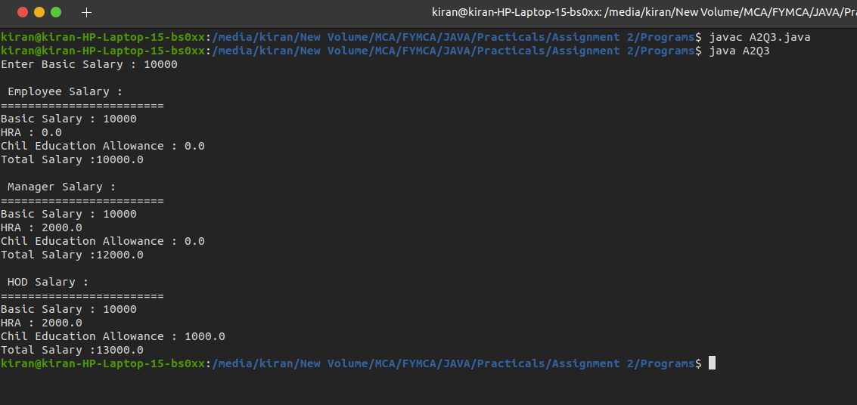

4. Imagine a publishing company that markets both Books and Video-Cassettes versions

of its works. Create a class Publication that stores the title (a string) and price (a float)

of publication. From this class derive two classes: Book, which adds a page_count

(integer) and a class Tape, which add a playing_time in minutes (float). Each of these

three classes should have a getdata( ) and putdata() functions. Write a Java program

to test these classes.

**Solution :**

import java.util.*;

class Publication{

protected String title;

protected float price;

void getData(String title,float price){

this.title=title;

this.price=price;

}

void putData(){

System.out.println("Title : "+title);

System.out.println("Price : "+price);

}

}

class Book extends Publication{

private int page_count;

void getData(String title,float price,int page_count){

super.getData(title,price);

this.page_count = page_count;

}

void putData(){

System.out.println("\n Book");

super.putData();

System.out.println("Page Count : "+page_count);

}

}

class Tape extends Publication{

private float playing_time;

void getData(String title,float price,float playing_time){

super.getData(title,price);

this.playing_time = playing_time;

}

void putData(){

System.out.println("\n Tape");

super.putData();

System.out.println("Playing Time : "+playing_time);

}

}

class A2Q4{

public static void main(String args[]){

Scanner sc = new Scanner(System.in);

System.out.print("Enter Publication Title : ");

String title = sc.next();

System.out.print("Enter Publication Price : ");

int price = sc.nextInt();

System.out.print("Enter Number of Pages of Book : ");

int pages = sc.nextInt();

System.out.print("Enter Play Time of Tape :(in minutes) ");

float play_timing = sc.nextFloat();

Publication pub = new Publication();

Book book = new Book();

Tape tape = new Tape();

pub.getData(title,price);

book.getData(title,price,pages);

tape.getData(title,price,play_timing);

pub.putData();

book.putData();

tape.putData();

}

}

**Output :**

